Ex1: eda

age <- c(35, 65, 49, 30, 20, 40, 90, 54, 78, 45)

systolic_pressure <- c(122, 120, 120, 115, 130, 131, 118, 122, 120, 115)

diastolic_pressure <- c(83, 79, 78, 72, 90, 90, 82, 80, 82, 75)

calculate_stats <- function(data) {

n <- length(data)

min_val <- min(data)

max_val <- max(data)

median_val <- median(data)

mean_val <- mean(data)

variance_val <- var(data)

sd_val <- sd(data)

return(c(n, min_val, max_val, median_val, mean_val, variance_val, sd_val))

}

age_stats <- calculate_stats(age)

systolic_pressure_stats <- calculate_stats(systolic_pressure)

diastolic_pressure_stats <- calculate_stats(diastolic_pressure)

stats_table <- data.frame(

Statistic = c("Number of samples", "Minimum value", "Maximum value", "Median", "Mean", "Variance", "Standard deviation"),

Age = age_stats,

Systolic_Pressure = systolic_pressure_stats,

Diastolic_Pressure = diastolic_pressure_stats

)

print(stats_table)

demo<- read.csv('Iris.csv')

head(demo)

tail(demo)

summary(demo)

mean(demo $Petal.Width)

hist(iris$Petal.Width,

main = "Histogram of Petal Width",

xlab = "Petal Width",

col = "lightblue",

border = "black")

versicolor_data <- subset(iris, Species == "versicolor")

vir_petal<- sd(virginica_data$Petal.Width)

print(versi_petal)

setosa_data <- subset(iris, Species == "setosa")

virginica_data <- subset(iris, Species == "virginic")

results <- data.frame(

Statistic = c(

"mean", "median",

"Variance", "Standard deviation"

),

versi= c( versi_petal

),

setosa = c(

setosa_petal

),

virginica = c(vir_petal)

)

# Printing the results

print(results)

qn1.

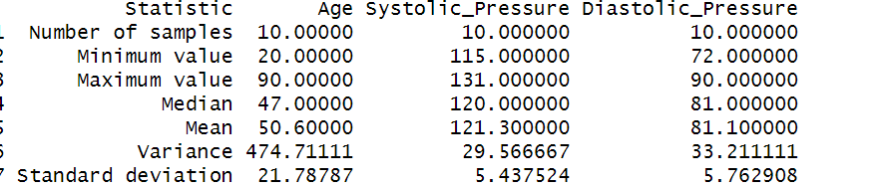

qn2.

